**ASSIGNMENT 1 FRONT SHEET**

|  |  |  |  |
| --- | --- | --- | --- |
| **Qualification** | **BTEC Level 5 HND Diploma in Computing** | | |
| **Unit number and title** | Unit 16: Cloud computing | | |
| **Submission date** | June 9th, 2022 | **Date Received 1st submission** |  |
| **Re-submission Date** |  | **Date Received 2nd submission** |  |
| **Student Name** | Mai The Duc | **Student ID** | DucMTGCH200681 |
| **Class** | GCH0907 | **Assessor name** | Do Quoc Binh |
| **Student declaration**  I certify that the assignment submission is entirely my own work and I fully understand the consequences of plagiarism. I understand that making a false declaration is a form of malpractice. | | | |
|  |  | **Student’s signature** |  |

**Grading grid**

|  |  |  |  |  |  |  |
| --- | --- | --- | --- | --- | --- | --- |
| P1 | P2 | P3 | P4 | M1 | M2 | D1 |
|  |  |  |  |  |  |  |

|  |  |  |
| --- | --- | --- |
| **❒ Summative Feedback: ❒ Resubmission Feedback:** | | |
| **Grade:** | **Assessor Signature:** | **Date:** |
| **Internal Verifier’s Comments:** | | |
| **Signature & Date:** | | |

Table of Contents

Table of Figures 4

I. Introduction 5

II. Overview cloud computing 5

III. Client-Server 6

III.1. Client 6

III.2. Server 7

III.3. Relation between Client and Server 8

IV. Peer-to-peer (P2P) 8

IV.1. Advantage of Peer-to-peer network 9

IV.2. Example of Peer-to-peer 10

V. High Performance Computing 11

V.1. Definition 11

V.1.1. Parallel Computing 11

V.1.2. Cluster 12

V.1.3. Distributed 13

V.2. Example 14

# Table of Figures

Figure 1: Cloud Computing 5

Figure 2: Client-Server 6

Figure 3: Client-Server 2 8

Figure 4: P2P 9

Figure 5: P2P example 10

Figure 6: Parallel Computing 11

Figure 7: Cluster 12

Figure 8: Distributed 13

Figure 9: HPC example 14

Figure 10: Public cloud 16

Figure 11: Public cloud 2 17

Figure 12: Private cloud 18

# Introduction

In this assignment, the scenario put me in a role of IT data specialist for a toys company called ATN. The company has revenue over 700.000$/year. But unfortunately, the company system is quite ineffective. My job is to design a cloud system. Therefore, my company will have a whole new system to communicate and update information between shops and also we can check the stock update information in real time. Fundamentals of cloud computing, the solution for the scenario and detailed design will de discuss in this report.

# Overview cloud computing

The delivery of computing resources over the internet, such as storage, processing power, databases, networking, analytics, artificial intelligence, and software applications, is known as cloud computing (the cloud). Companies can access the computational assets they need when they need them by outsourcing these resources rather than purchasing and maintaining a physical, on-premise IT infrastructure. This allows for more flexible resources, faster innovation, and cost savings. A cloud migration is often linked to data and IT modernization for many businesses (Zettler, 2022).

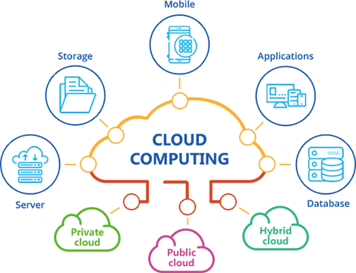

Figure 1: Cloud Computing

# Client-Server

The process of delivering information from a server to a digital device is known as the client-server model. The client-server model describes how devices interact with data stored on servers. It enables multiple clients to open applications or download files from a single server, ensuring consistency across all devices. Client-server models are widely used in all industries that store and access data on servers (Team, 2022).

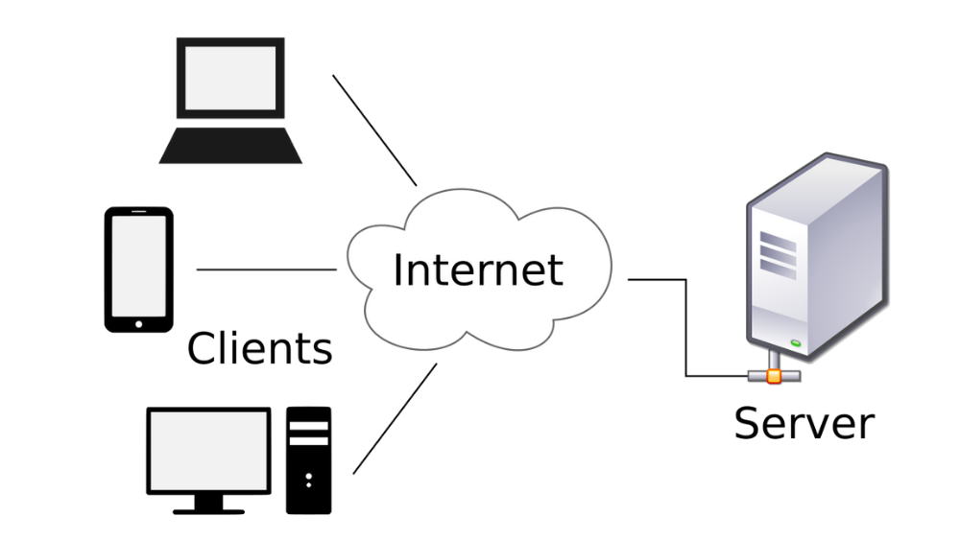

Figure 2: Client-Server

## III.1. Client

When we talk about a client, we're talking about a person or an organization who uses a specific service. A Client is a computer (Host) in the digital world, capable of receiving information or using a specific service from the service providers (Servers) (syedmodassirali, 2019).

According to ‘indeed’ company, 2022, clients are divided into three categories by IT professionals. Server requesters is another name for them. These are some of them:

1. Thin clients:

To perform many of a device's main functions, a thin client requires the resources and processing power of a server.

* 1. Hardware Thin Clients Examples: Leadtek Virtual Desktop System, Oracle/Sun’s Sun Ray.
  2. Software Thin Clients Examples: X11, Citrix ICA.

1. Thick clients:

They are devices that can process large amounts of data and perform multiple functions without the assistance of a server. Example like cellphone, computer, tablet,..

1. Hybrid clients:   
   These devices can process data on their own, but they must rely on a server to store data for larger or more frequent processing tasks.

## III.2. Server

When we talk about servers, we're talking about a person or a medium who serves something. A server is a remote computer that provides information (data) or access to specific services in the digital world (syedmodassirali, 2019).

According to ‘indeed’ company, 2022, to establish a client-server connection, IT professionals use one of four servers. The following are examples of client-server models:

1. Database servers:

They are commonly used for programs that contain highly structured data, such as marketing spreadsheets or accounting files. For example, Microsoft SQL server, phpMyAdmin, MySQL,…

1. Application servers:

They allow users to access internet applications without having to download them to their device. For example, JBoss, Websphere, Tcat Server, Oracle OC4J,…

1. Web servers:

They are used to make it easier for clients to access the internet. For example, Apache Web Server, Boa Webserver, Lighttpd, Savant,…

1. Computing servers:

A computing server provides additional storage and processing power beyond what a typical device can provide.

## III.3. Relation between Client and Server

A request-response messaging pattern is when messages are sent back and forth between the two. A request will be sent by the client, and the server must respond.

For a variety of reasons, this type of relationship is beneficial. For starters, all of the necessary data can be stored on the server in one location. It is much easier to protect your data and provide authorization with this method. Furthermore, the server does not need to be in close proximity to the client in order for the data to be accessed efficiently. Finally, because everything in the client-server model is independent of one another, upgrading the modes is simple.

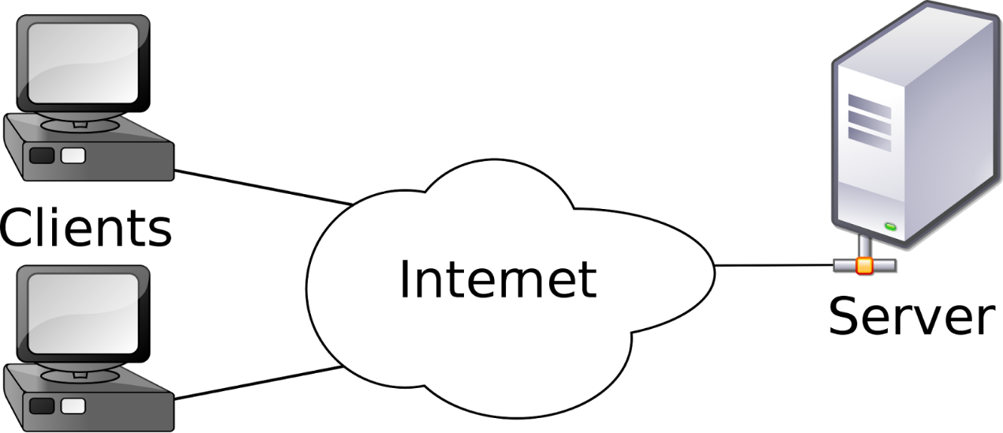

Figure 3: Client-Server 2

# Peer-to-peer (P2P)

A peer-to-peer network is an IT infrastructure that allows two or more computer systems to communicate and share resources without the need for a separate server or server software. P2P networks can be set up in the workplace by physically connecting computers or by creating a virtual network. You can also configure computers to act as network clients and servers (Team, What Is a Peer-to-Peer (P2P) Network?, 2021).

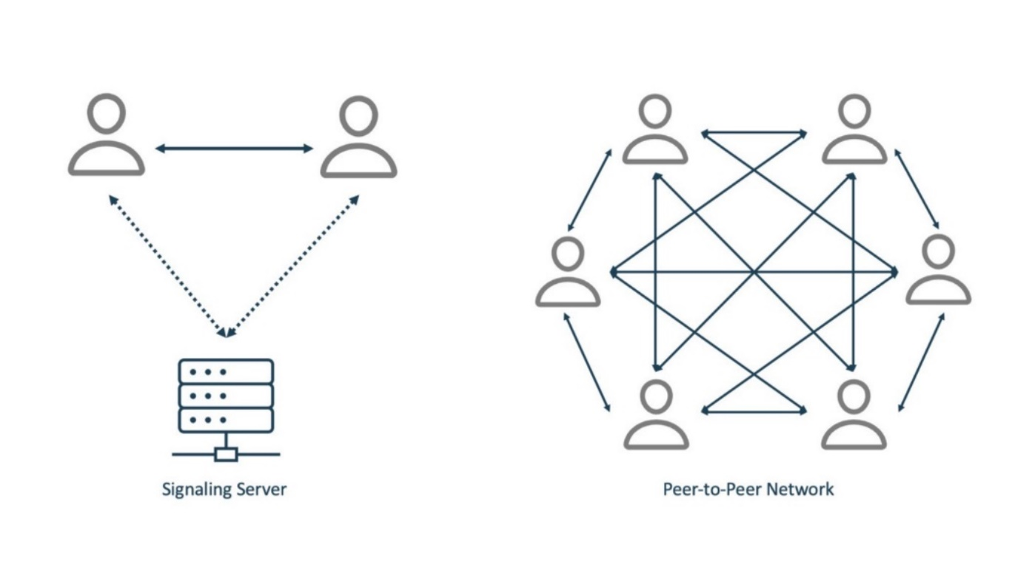

Figure 4: P2P

## IV.1. Advantage of Peer-to-peer network

According to ‘indeed’ company, 2021, A P2P network can provide many benefits to its users due to its architecture, including:

* Easy file sharing: A sophisticated peer-to-peer network can quickly share files over long distances. Anytime you want, you can get to your files.
* Reduced costs: When setting up a P2P network, there is no need to buy a separate computer to serve as a server. It does not necessitate the use of a network operating system or the employment of a full-time system administrator.
* Adaptability: A P2P network can easily expand to include new clients. These networks are more flexible than client-server networks because of this benefit. Its scalability is one of its most appealing features.
* Reliability: Unlike a client-server network, which can fail if the central server goes down, a peer-to-peer network will continue to function even if the central server goes down. If one computer fails, the others continue to function normally. Because traffic is distributed across multiple computers, bottlenecking is avoided.
* High performance: While a client-server network suffers as more clients join, a peer-to-peer network can actually improve its performance as more people join. Because each client in a P2P network is also a server contributing resources to the network, this is the case.
* Efficiency: Emerging P2P networks allow devices with different resources to collaborate to benefit the entire network.

## IV.2. Example of Peer-to-peer

A P2P (peer-to-peer) network architecture is commonly used to share large files over the internet. Some online gaming platforms, for example, use peer-to-peer (P2P) to distribute games between users. Blizzard Entertainment uses peer-to-peer (P2P) distribution for Diablo III, StarCraft II, and World of Warcraft. Wargaming, another major publisher, does the same thing with its World of Tanks, World of Warships, and World of Warplanes games. Others, such as Steam or GOG, prefer to maintain dedicated download servers around the world rather than use P2P.

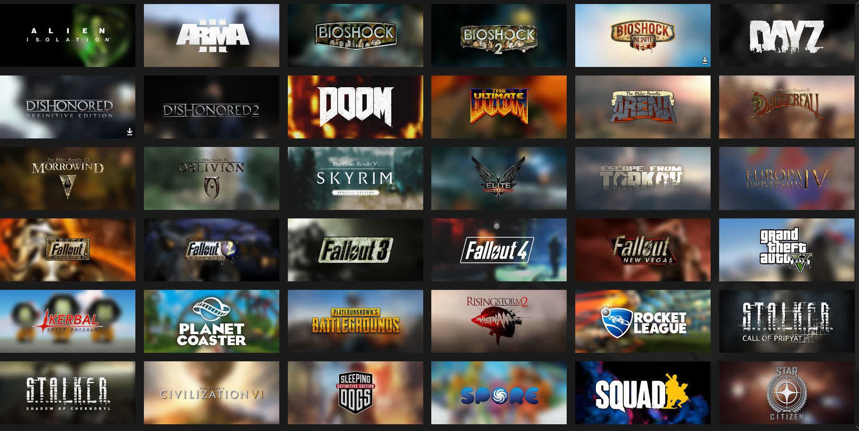

Figure 5: P2P example

# High Performance Computing

## V.1. Definition

The ability to process data and perform complex calculations at high speeds is known as high performance computing (HPC). To put it into perspective, a 3 GHz processor on a laptop or desktop computer can perform approximately 3 billion calculations per second. While this is significantly faster than any human, it pales in comparison to HPC solutions that can perform quadrillions of calculations per second (NetApp, 2022).

### V.1.1. Parallel Computing

Parallel computing HPC systems involve hundreds of processors, with each processor running calculation payloads simultaneously.

Parallel computing is the process of breaking down larger problems into smaller, independent, and often similar parts that can be executed concurrently by multiple processors communicating via shared memory, with the results being combined as part of an overall algorithm. Parallel computing's main goal is to increase available computing power for faster application processing and problem solving (Heavy.AI, 2022).

According to Heavy.AI, 2022, Parallel computer architecture can be found in a wide range of parallel computers, which are classified according to the level of parallelism supported by the hardware. To make the most of these machines, parallel computer architecture and programming techniques work together. The following are examples of parallel computer architectures:

* 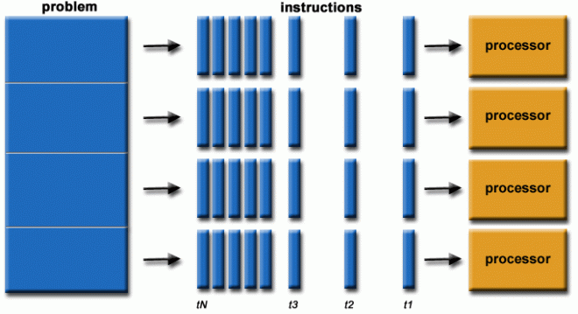Multi-core computing
* Symmetric multiprocessing
* Massively parallel computing

Figure 6: Parallel Computing

### V.1.2. Cluster

Cluster computing is a type of parallel HPC system consisting of a collection of computers working together as an integrated resource. It includes scheduler, compute, and storage capabilities.

Cluster computing is a grouping of closely or loosely connected computers that collaborate to act as a single entity. The connected computers perform operations in concert, giving the impression of a single system. Fast local area networks connect the clusters in most cases (LANs) (shubhikagarg1999, 2021).

Advantage of Cluster Computing:

1. High Performance
2. Easy to manage
3. Scalable
4. Expandability
5. Availability
6. Flexibility

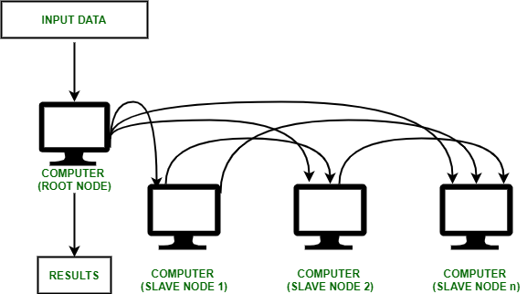

Figure 7: Cluster

### V.1.3. Distributed

Distributed computing HPC systems connect the processing power of multiple computers within a network. The network can be a grid at a single location or distributed across a wide area in different places, linking network, compute, data and instrument resources.

A distributed computer system is made up of multiple software components that run on different computers but work together as one. A distributed system's computers can be physically close together and connected through a local network, or they can be geographically separated and connected through a wide area network. A distributed system can be made up of a variety of components, including mainframes, personal computers, workstations, and minicomputers. Distributed computing aims to make a network behave like a single computer (IBM, 2021).



Figure 8: Distributed

## V.2. Example

According to Rice, 2019, HPC is being used by researchers at the University of Texas at Austin to improve cancer treatment. Researchers scanned petabytes of data for correlations between a cancer patient's genome and the composition of their tumors in one particularly interesting project.

"[HPC] has been vital to our analysis of cancer genomics data, both for providing the necessary computational power and the security needed for handling sensitive patient genomic datasets," said Vishy Iyer, a professor of molecular bioscience and one of the project’s leaders.



Figure 9: HPC example

# Deployment Models

Based on ownership, scale, and access, as well as the cloud's nature and purpose, the cloud deployment model identifies the specific type of cloud environment. A cloud deployment model determines where your servers are located and who has control over them. It describes how your cloud infrastructure will look, what you can change, and whether you will be provided with services or must create everything yourself. Cloud deployment types also define the relationships between your infrastructure and your users (sameekshakhandelwal1712, 2021).

According to GeeksforGeeks, 2021, The following are types of cloud computing deployment models:

1. Public cloud
2. Private cloud
3. Hybrid cloud
4. Community cloud

## VI.1. Public Deployment

The public cloud is an IT model in which a third-party provider manages on-demand computing services and infrastructure that is shared across multiple organizations via the public Internet. Public cloud service providers may charge users a monthly or per-use fee for cloud-based services such as infrastructure as a service (IaaS), platform as a service (PaaS), or software as a service (Saas), removing the need for users to host these services on-site in their own data center (vmware, 2022).

A public cloud is a cloud deployment model in which a provider owns and operates computing resources that are shared across multiple tenants via the Internet (vmware, 2022).

Many enterprise companies are turning to the public cloud as a way to scale existing IT resources on demand without having to invest in new physical infrastructure. A company can, for example, purchase a virtual desktop license rather than a physical desktop machine. In minutes, the virtual desktop can be activated or deactivated, and it can be located anywhere, at any time (vmware, 2022).

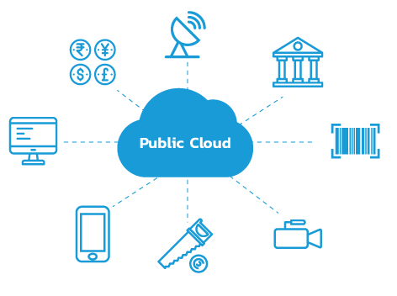

Figure 10: Public cloud

According to GeeksforGeeks, 2021, the advantages of public cloud model are:

1. Minimal Investment: Because it is a pay-per-use service, there is no large upfront investment, making it ideal for businesses that require immediate access to resources.
2. There are no setup fees: Because the cloud service providers cover the entire infrastructure, there is no need to set up any hardware.
3. It is not necessary to manage the infrastructure: Infrastructure management is not required when using the public cloud.
4. No maintenance: Maintenance is not required because the service provider performs it (Not users).
5. Dynamic Scalability: On-demand resources are available to meet your company's needs.

### Example

According to Upadhyay, 2020, Amazon, Google, Microsoft, IBM, Oracle, and others offer public cloud services. Hundreds or thousands of people share resources. The public cloud infrastructure of Google Cloud Platform is a part of Google Cloud Storage public services. Public cloud services include Gmail and Google Drive. An email account, for example, is protected by a password, but the hardware on which it is stored is shared by millions of people. We've compiled a list of the various services offered by public cloud providers in the market:

* Microsoft Azure ExpressRoute
* Google Cloud Interconnect
* AWS Direct Connect
* Blue cloud by IBM
* Alibaba Cloud
* Oracle Cloud FastConnect

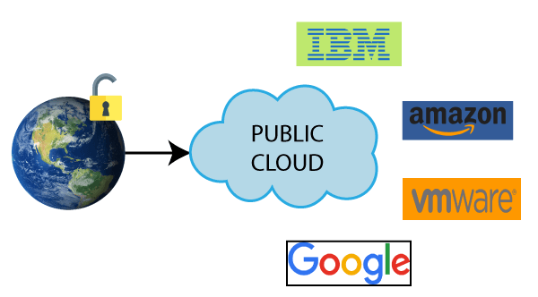

Figure 11: Public cloud 2

## VI.2. Private Deployment

The private cloud deployment model is diametrically opposed to that of the public cloud. It's a one-on-one situation for a single person (customer). You don't have to share your hardware with anyone. The difference between a private and a public cloud is how all of the hardware is handled. The ability to access systems and services within a given border or organization is referred to as the "internal cloud." The cloud platform is deployed in a secure cloud-based environment protected by powerful firewalls and managed by an organization's IT department. The private cloud allows for more control and flexibility over cloud resources (sameekshakhandelwal1712, 2021).

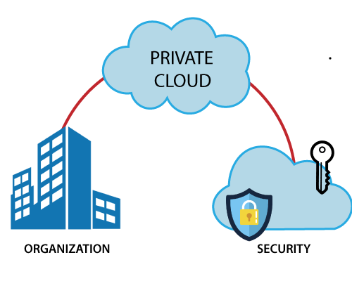

Figure 12: Private cloud

According to GeeksforGeeks, 2021, the advantages of Private cloud model are:

* Better Control: You have more control because you are the property's sole owner. You take full control of service integration, IT operations, policies, and user behavior.
* Data Security and Privacy: It's ideal for storing corporate data that only authorized employees have access to. Improved access and security can be achieved by segmenting resources within the same infrastructure.
* Support Legacy Systems: This method is intended for legacy systems that are unable to connect to the public cloud.
* Customization: Unlike a public cloud deployment, a private cloud enables a company to customize its solution to meet its unique requirements.

### Example

Best private cloud provider:

* HPE
* VMware
* Dell
* Oracle
* IBM / Red Hat
* Microsoft
* Cisco
* NetApp
* Amazon Web Services

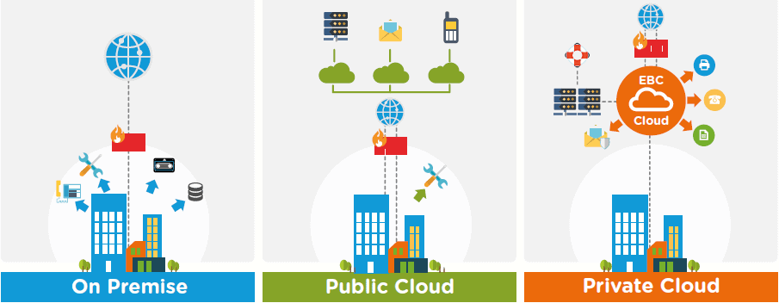

Figure 13: Private cloud 2

## VI.3. Hybrid cloud

Hybrid cloud computing combines the best of both worlds by bridging the public and private worlds with a layer of proprietary software. With a hybrid solution, you can host the app in a secure environment while benefiting from the cost savings of the public cloud. Depending on their needs, organizations can use a combination of two or more cloud deployment methods to move data and applications between clouds (sameekshakhandelwal1712, 2021).

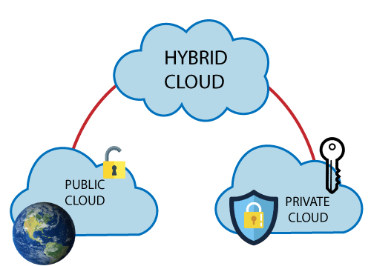

Figure 14: Hybrid cloud

According to GeeksforGeeks, 2021, the advantages of Hybrid cloud model are:

* Flexibility and control: Companies with more flexibility can create customized solutions to meet their specific requirements.
* Cost: Because public clouds allow for scalability, you'll only be charged for additional capacity if you need it.
* Security: Because data is separated properly, the chances of data theft by attackers are greatly reduced

### Example

Data management:

Data must be integrated, transformed, and made available in real-time for decision support across the organization, with customers, and with business partners, with hybrid clouds and data spending across multiple clouds. Cloud data management platforms can work in both hybrid and non-hybrid environments, making the data management solution a hybrid in and of itself to support the need for quick, actionable responses to customers and the overall service value chain.



Figure 15: Hybrid cloud 2

## VI.4. Community cloud

It enables a group of organizations to access systems and services. It's a distributed system that's built by combining the services of various clouds to meet the needs of a community, industry, or business. The community's infrastructure could be shared between organizations with similar concerns or tasks. It is usually managed by a third party or a consortium of one or more community organizations (sameekshakhandelwal1712, 2021).

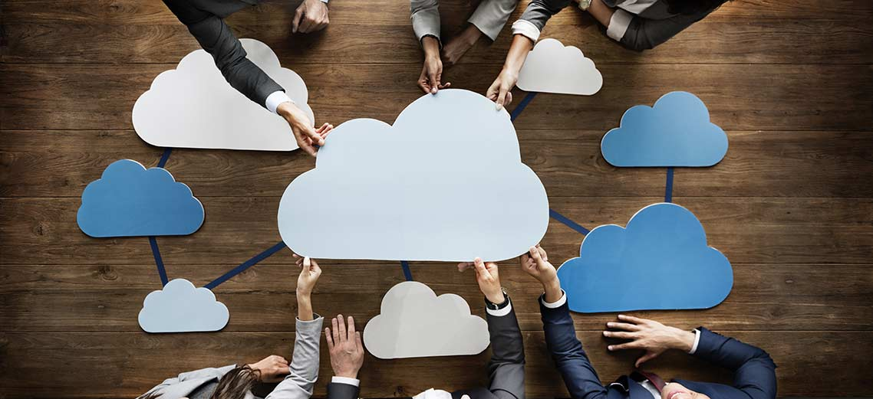

Figure 16: Community cloud

According to GeeksforGeeks, 2021, the advantages of Community cloud model are:

* Cost Effective: Because the cloud is shared by multiple organizations or communities, it is cost-effective.
* Security: The community cloud is more secure.
* Shared resources: It allows you to share resources, infrastructure, and other resources with multiple organizations.
* Collaboration and data sharing: It's good for both collaboration and data sharing.

### Example

Top 5 Community Cloud Providers to Consider in 2021:

1. Cisco
2. Cloud4C
3. Hewlett Packard Enterprise (HPE)
4. IBM
5. Microrsoft

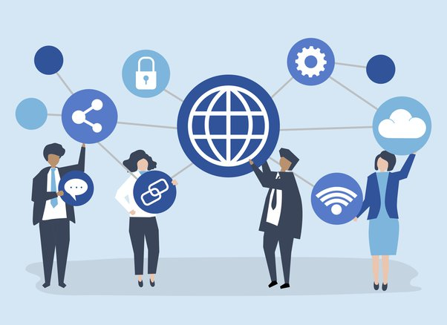

Figure 17: Community cloud 2

# Cloud Service models

## VII.1. Infrastructure as a Service

Infrastructure as a Service (IaaS) is a cloud computing service that allows businesses to rent or lease servers in the cloud for compute and storage. Users can run any operating system or application on the rented servers without incurring the costs of server maintenance and operation. Another benefit of Infrastructure as a Service is that it allows customers to access servers in close proximity to their end users. IaaS scales up and down automatically based on demand and offers a guaranteed service-level agreement (SLA) in terms of uptime and performance. It eliminates the need for data centers to manually provision and manage physical servers (AVINetworks, 2022).



Figure 18: IaaS

According to AVINetworks, 2022, for a business, Infrastructure as a Service (IaaS) can be more cost-effective than owning and managing its own infrastructure. Instead of purchasing the necessary infrastructure, new applications can be tested using an IaaS provider.

Infrastructure-as-a-service also has the following benefits:

* Disaster recovery and continuity: Having cloud services in multiple locations allows you to access applications and data in the event of a disaster or outage.
* Faster scaling: Quickly scale up and down resources according to application demand in all categories of cloud computing.
* Core focus: IaaS allows enterprises to focus more on core business activities instead of IT infrastructure and computing resources.

## VII.2. Platform as a Service

Developers who use the Platform-as-a-Service (PaaS) model rent everything they need to build an app from a cloud provider, including development tools, infrastructure, and operating systems. This is one of the three cloud computing service models. PaaS greatly simplifies web application development because all backend management is done behind the scenes, away from the developer's view. Although there are some similarities between PaaS and serverless computing, there are many significant differences (CLOUDFLARE, 2022).

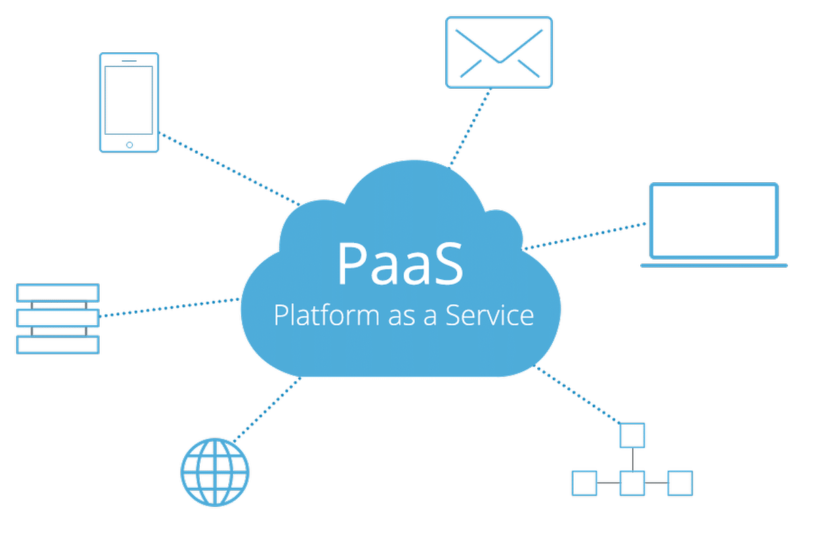

Figure 19: PaaS

According to CLOUDFLARE, 2022, the benefits of Platform-as-a-Service are:

* Faster time to market: PaaS allows developers to build applications faster than they could if they had to worry about constructing, configuring, and provisioning their own platforms and backend infrastructure. All they have to do with PaaS is write the code and test the application, and the vendor will take care of the rest.
* One environment from start to finish: PaaS allows developers to create, test, debug, deploy, host, and update their apps all in the same place. This allows developers to ensure that a web application will work properly as a hosted application before releasing it, as well as simplifying the application development lifecycle.
* Price: In many cases, PaaS is more cost-effective than using IaaS. PaaS customers save money because they don't have to manage or provision virtual machines. Furthermore, some vendors offer a pay-as-you-go pricing model, in which the vendor only charges for the computing resources used by the application, saving customers money. However, each vendor's pricing structure varies slightly, and some platform providers charge a monthly flat fee.
* Ease of licensing: All licensing for operating systems, development tools, and everything else included in the PaaS platform is handled by the PaaS provider.

## VII.3. Software as a Service

Software-as-a-Service (SaaS) is a software licensing model in which users pay a monthly fee for access to software that is hosted on external servers rather than on internal servers (Grant, 2021).

Typically, Software as a Service is accessed via a web browser, with users logging in with a username and password. Instead of having to install the software on their own computer, users can access the program through the Internet (Grant, 2021).

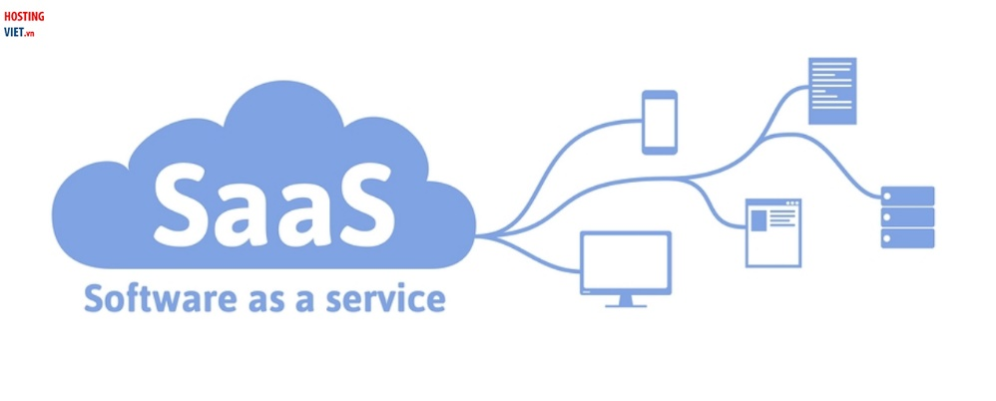

Figure 20: SaaS

According to Grant, 2021, Compared to traditional software licensing models, SaaS has a number of advantages. There is less demand for the licensing company to invest in new hardware because the software does not reside on its servers.

It is simple to set up, update, and debug, and it can be less expensive (at least in the short term) because users pay for SaaS as they go rather than purchasing multiple software licenses for multiple computers.

* Accessible from anywhere
* Cost effective
* Easy to implement, update, and debug
* Easy to scale

## VII.4. Comparing Service models